****GREENWOOD PUBLIC SCHOOL, ADITYAPURAM**

**OUR MOTTO - DEVELOPMENT WITH DELIGHT**

**SYLLABUS FOR THE MONTH OF AUGUST (2019-20)**

**CLASS-NURSERY**

|  |  |  |  |
| --- | --- | --- | --- |
| **SUBJECTS** |  | **ACTIVITY+USE OF ICT** | **PARENTS INVOLVEMENT** |
| **English** | **Oral :** I have you , A for Apple.  **Written** :Alphabets A,B,C,D,E & Revision A-E  **Workbook:** Page No. 8-12  **Theme :** Myself  **Sentence structure** : I am a girl / I am a boy  **Vocabulary Building**: Eating , Smiling , Playing  **Recognition Alphabets:** A to H | C:\Users\123\Desktop\TC\cartoon-kids-with-abcdef-letters-vector-19913776.jpgC:\Users\123\Desktop\images\maxresdefault.jpg | Help your child in learning rhymes and written work |
| **Hindi** | **Oral : dfork,¡ &** vPNh f'k{kk ] ckny xjts A  **okkD; jpuk %**  **Loj %** अ- ऊ  **Written** : स्वर अ-ऊ तक  **Recognition Alphabets:** स्वर अ-ऊ तक  **Workbook:** Page no 10-13 | C:\Users\123\Desktop\images\hqdefault.jpg | dfork,sa ;kn djok,Wa rFkk o.kksaZ dh igpku fp=ksa +}kjk djok,W! |
| **Maths** | **Oral :** Counting 1-10  **Concepts** :  **Written**: Digit 3,4,5 & Revision 1-5 Recognition 1-5  **Workbook:** Page no 8-11 | C:\Users\123\Desktop\images\maxresdefault (5).jpg | Motivate your child in counting objects and learning tables. |
| **Drawing** | Page no 5,6 |  |  |
| **G.K.** | **Oral** : Fruits name , Vegetables Name **C:\Users\123\Desktop\images\chess.jpg** | PPT on Flowers & Fruits  C:\Users\123\Desktop\images\pics-of-cartoon-fruits.jpg | Help your child to recog. the vegetables and Fruits. |
| **Music / Dance** | National Anthem |  |  |
| **V.E.** | Always speak the truth | C:\Users\123\Desktop\images\school-building-md.pngPPT on School | Talk to your child about the school |
| **Physical Education** | Races |  | Take your child to a park and play some games. |
| **Language Development** | Sit Straight , Come forward , Go backward , Get in a line. |  |  |
| **Conversation** | **English Conversation**  **1. How are you?**  Ans-I am fine thank you.  **2. In which class do you study?**  Ans-I study in nursery class.  **3.What is the name of your school?**  Ans-The name of my school is Greenwood Public School. | **Hindi Conversation**  **प्रश्न 1-** आप कितने वर्ष के हैं ?  **उत्तर -** मैं तीन वर्ष का / की हूँ !  **प्रश्न 2-** आप किस कक्षा मेँ पढ़ते हैं ?  **उत्तर -** मैं नर्सरी मेँ पढ़ता / पढ़ती हूँ !  **प्रश्न 3-** आपके स्कूल का क्या नाम हैं?  **उत्तर -** मेरे स्कूल का नाम ग्रीनवुड पब्लिक स्कूल हैं ! | Help your child in learning Conversation Que/Ans |

**Things we use in rainy season**

**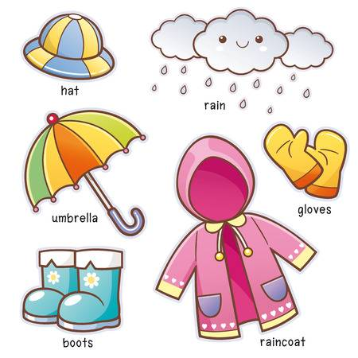**

**Opposites**

Big × Small

Tall × Short

Sit × Stand

In × Out

Come × Go

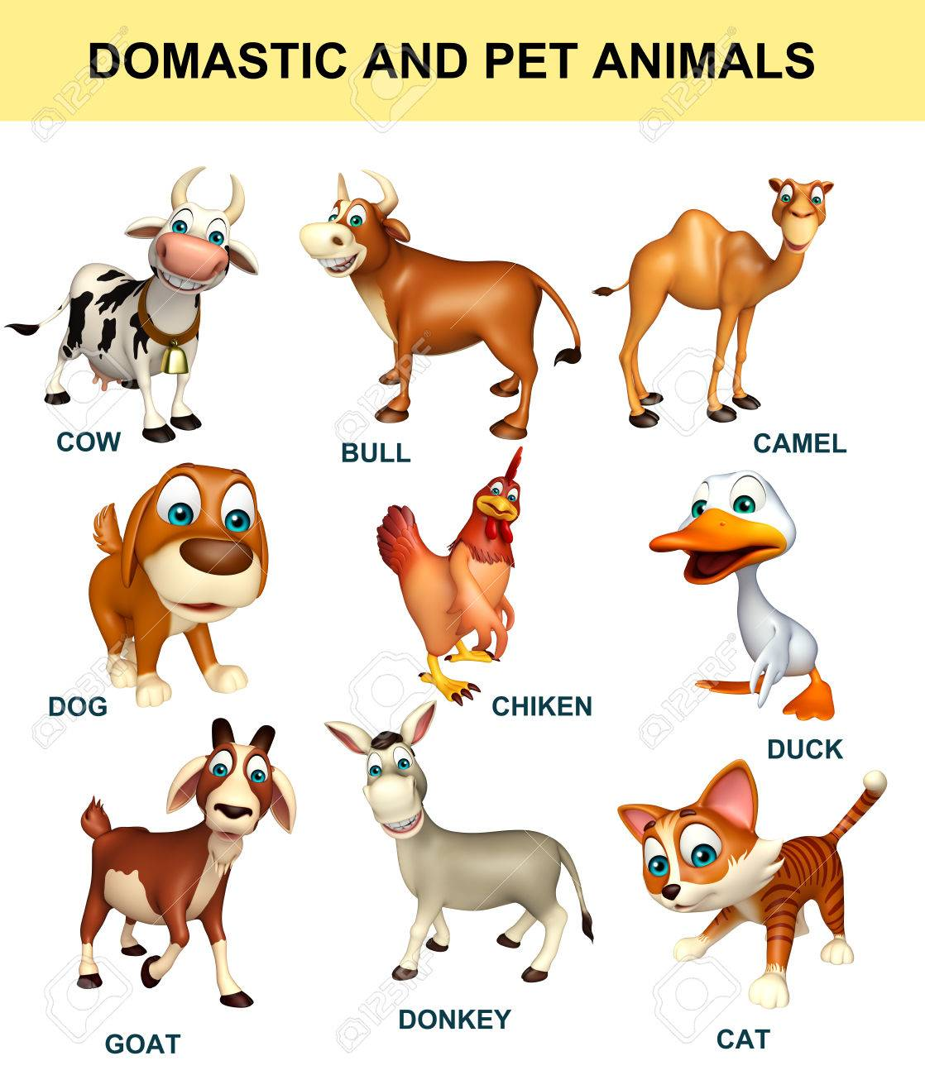

**Stars of July Month Nursery**

****

1. Ananya Bhadouria

2. Heenal Dubey

3. Ritik Dubey

****GREENWOOD PUBLIC SCHOOL, ADITYAPURAM**

**OUR MOTTO - DEVELOPMENT WITH DELIGHT**

**SYLLABUS FOR THE MONTH OF AUGUST(2019-20)**

**CLASS-L.K.G**

|  |  |  |  |
| --- | --- | --- | --- |
| **SUBJECTS** |  | **ACTIVITY+USE OF ICT** | **PARENTS INVOLVEMENT** |
| **English** | **Oral:-Rhymes-** Little Robin, old mother Hubbard, Revision of Previous Rhymes  **Reading –**Alphabet sounds- ‘D’, ‘E’, ‘F’ and ‘G’ Revision of July month syllabus  **Written:**small cursive letters (e – l), Dictation, Revision of April and July Month syllabus.  **Vocabulary Building:** Monsoon , Rain , Thunder , Sink , Float | **C:\Users\123\Desktop\images\45092984-stock-vector-happy-school-kids-with-alphabet-blocks.jpg** | **Help your child in learning rhymes and written work** |
| **Hindi** | **मौखिक**: **कविताएँ -** फूल , टीचर , और अप्रैल जुलाई महीनों की कविताओं का पुनः अभ्यास  **Reading: व्यंजन वर्ण** क से न तक  **Written**: **व्यंजन वर्ण** ट से न तक , श्रुतलेख **स्वर वर्ण** अ से अ: तक और **व्यंजन वर्ण** क से तक का पुनः अभ्यास ! | **C:\Users\123\Desktop\TC\hindi-alphabets-puzzle-500x500.jpg**  **C:\Users\123\Desktop\images\images.jpg** | dfork,sa ;kn djok,Wa rFkk o.kksaZ dh igpku fp=ksa +}kjk djok,W! |
| **Maths** | **Oral :** Counting 1- 100, Table of 2,3 number names 1-10, Funtastic Maths unit – 1 Page no. 5-14  **Written :**Counting 81- 100, table of 2 reverse counting from 20 -1 Revision of April and July month syllabus, Unit 1 Page no 10 – 14. | **C:\Users\123\Desktop\images\download (1).jpg**  **C:\Users\123\Desktop\TC\Tabbl-of-2.png** | **Motivate your child in counting objects and learning tables.** |
| **G.K. Oral** | Oral- The classroom, The family | **C:\Users\123\Desktop\images\800px_COLOURBOX20120355.jpgC:\Users\123\Desktop\images\download (4).jpg** | **Teach your child the names of your family members.** |
| **Drawing** | Page no 6 and 7 (Igloo and Starfish) |  |  |
| **Music / Dance** | Rakhi song and Patriotic song |  |  |
| **V.E.** | Be Polite |  | **Motivate your child to help others** |
| **Physical Education** | Fun games |  | **Take your child for a nature walk.** |
| **Language Development** | Tie my shoelaces, Please open my lunch box, Come with me, Pack my bag, Please give me a pencil. |  |  |

|  |  |  |
| --- | --- | --- |
| **Conversation** | **English Conversation**  **Q.1 Name the National Flag of India.**  Ans- Tricolour  **Q.2 When do we celebrate Independence Day?**  **Ans-** 15th August  **Q.3 What is the name of National Anthem ?**  Ans- Jana – Gana - Mana  **Q.4 Why do we celebrate Janamashtami?**  **Ans-**Lord Krishna’s birthday is celebrated as Janamashtmi.  **Q.5 Raksha Bandhan is a festival of relationship between?**  Ans-Brother – sister | **Hindi Conversation**  **प्र1 रक्षाबंधन किसके प्यार का प्रतीक है?**  **उत्तर-**रक्षा बंधन भाई बहन के प्यार का प्रतीक है !  **प्र2 रक्षाबंधन कौन से माह में मनाया जाताहै?**  **उत्तर -** रक्षा बंधन श्रावण मास की पूर्णिमा को मनाया जाता है !  **प्र3 हमारा राष्ट्र गान कौन सा है!**  **उत्तर** जन- गण- मन  **प्र4 Lora=rk fnol dc euk;k tkrk gS\**  **उत्तर-** **Lora=rk fnol 15 vxLr dks euk;k tkrk gSA**  **प्र5 भगवान श्री कृष्ण का tUe कहाँ हुआ था?**  **उत्तर -** भगवान श्री कृष्ण का जनम मथुरा में हुआ था !  **प्र6 भगवान श्री कृष्ण ने किसको मारा था?**  **उत्तर–** भगवान श्री कृष्ण ने कंस को मारा था ! |

**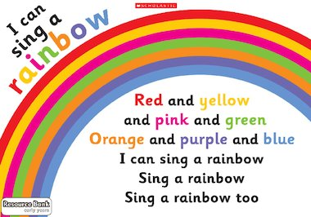**

**Stars of July Month (LKG) **

1.Vihan Singh Rathod

2.Subindu Singh

3.Srashti Uraiya

4.Arsh Saifi

5.Adrika Bhadoriya

6.Saloni Singh

**वर्षा रानी**

**चमचम चमचम बिजली चमके,**

**रिमझिम रिमझिम बादल बरसे,**

**गरज गरज कर करते शोर,**

**छाई काली घटा घनघोर !**

**प्यारी धरती की प्यास बुझाने आई वर्षा हमें भिगोने,**

**मैं तो इसकी दीवानी सबकी प्यारी वर्षा रानी!**

**Experimentation:**

**Different experiments related to properties of water will be conducted in the class room:**

1. Water has no colour.
2. Water has no shape.
3. Water has no taste.

****GREENWOOD PUBLIC SCHOOL, ADITYAPURAM**

**OUR MOTTO - DEVELOPMENT WITH DELIGHT**

**SYLLABUS FOR THE MONTH OF AUGUST(2019-20)**

**CLASS-U.K.G.**

|  |  |  |  |
| --- | --- | --- | --- |
| **SUBJECTS** |  | **ACTIVITY+USE OF ICT** | **PARENTS INVOLVEMENT** |
| **English** | **Oral:-Rhymes-** After A Bath, Wee Wellie Winki  **Reading –**Page No. 11, 12, 13  **Written :**Chapter- 11 to 18 Vowel ‘O’ with ‘e’ words with ‘oo’ sound, vowel ‘u’ with ‘e’ words with ‘Ss’ sound, words with ‘th’ sound, words with ‘sh’ sound, words with ‘Ll’ sound, words with ‘ch’ sound.  **Workbook:** Pg. No 5,6,7,8 | **C:\Users\123\Desktop\images\45092984-stock-vector-happy-school-kids-with-alphabet-blocks.jpg** | **Help your child in learning rhymes and written work** |
| **Hindi** | **मौखिक**: **कविताए:** आलूबोला , पारी , विलोमशब्द - रात - दिन  आगे - पीछे , ऊँचा - नीचा, अंदर - बाहर, सुबह - शाम  **Written:** पाठ - 6 से 9 तकईकीमात्रा , उकीमात्रा , ऊकीमात्रा , खालीस्थान , वाक्योंकोपूराकरो , उ, ऊकीमात्रालगाकरशब्दबनाना  **Reading:** Page no – 13, 14, 15 and 16  **Workbook:** Pg. No, 2,3,4,5 | **C:\Users\123\Desktop\images\images.jpg** | dfork,sa ;kn djok,WarFkk o.kksaZ dh igpku fp=ksa +}kjk djok,W! |
| **Maths** | **Oral :**Tables of 5 and 6, Counting from 101-150, Number names 21-30  **Written :** Counting from 101-151, table of 5, Back counting from 30-21 and work book. | **C:\Users\123\Desktop\images\download (1).jpg** | **Motivate your child in counting objects and learning tables.** |
| **E.V.S** | **Oral-** Places of Worship , Public Places  **Written-**Chapter-3 and4 My School Building, Living things, non- living things. Public Places and Places of worship.  Vocabulary Building – Garden, School, Teacher, Playground. |  |  |
| **G.K. Oral** | Oral- My family, names of fruits and flowers. | **C:\Users\123\Desktop\images\800px_COLOURBOX20120355.jpgC:\Users\123\Desktop\images\download (4).jpg** | **Visit a park with your child and show different types of flowers** |
| **Drawing** | Page no – 9,10 |  |  |
| **Music / Dance** | Patriotic Song |  |  |
| **V.E.** | Help others |  | **Motivate your child to help others** |
| **Physical Education** | Coin Races , Zig – Zag , Running |  | **Take your child for a nature walk.** |
| **Language Development** | Come in, Go out, Line Up, Sit Down |  |  |
| **Conversation**  **Stars of July Month (UKG-A)**  1.Prashant Bais  2.Anuj Singh Bhadouriya  3.Bhumika Tomar  4.Aaradhya Tomar | **National Flag of India.**  Ans- Tricolour  **Q.2 When do we celebrate Independence Day?**  **Ans-** 15th August  **Q.3 What is the name of National Anthem ?**  Ans- Jana – Gana - Mana  **Q.4 Why do we celebrate Janamashtami?**  **Ans-**Lord Krishna’s birthday is celebrated as Janamashtmi.  **Q.5 Raksha Bandhan is a festival of relationship between?**  Ans-Brother – sister  **Stars of July Month (UKG-B)**  1.Ankit Lodhi  2.Divyansh Jadon  3.Khushi Vanshkar  4.Aaradhya Rishishwar | **Hindi Conversation**  **प्र1 रक्षाबंधन किसके प्यार का प्रतीक है?**  **उत्तर-**रक्षा बंधन भाई बहन के प्यार का प्रतीक है !  **प्र2 रक्षाबंधन कौन से माह में मनाया जाताहै?**  **उत्तर -** रक्षा बंधन श्रावण मास की पूर्णिमा को मनाया जाता है !  **प्र3 हमारा राष्ट्र गान कौन सा है!**  **उत्तर** जन- गण- मन  **प्र4 Lora=rk fnol dc euk;k tkrk gS\**  **उत्तर-** **Lora=rk fnol 15 vxLr dks euk;k tkrk gSA**  **प्र5 भगवान श्री कृष्ण का tUe कहाँ हुआ था?**  **उत्तर -** भगवान श्री कृष्ण का जनम मथुरा में हुआ था !  **प्र6 भगवान श्री कृष्ण ने किसको मारा था?**  **उत्तर–** भगवान श्री कृष्ण ने कंस को मारा था ! | |

** Experimentation:**

**Different experiments related to properties of water will be conducted in the class room:**

1. Water has no colour.

**वर्षा रानी**

**चमचम चमचम बिजली चमके,**

**रिमझिम रिमझिम बादल बरसे,**

**गरज गरज कर करते शोर,**

**छाई काली घटा घनघोर !**

**प्यारी धरती की प्यास बुझाने आई वर्षा हमें भिगोने,**

**मैं तो इसकी दीवानी सबकी प्यारी वर्षा रानी!**

1. Water has no shape.
2. Water has no taste.

**Stars of July Month (UKG-B)**

**Stars of July Month (UKG-A)**